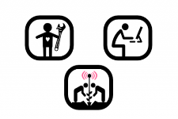
NABWC

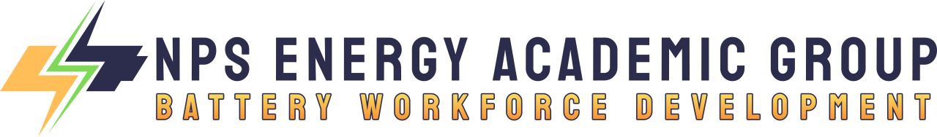
Battery Workforce Advisory Group
Phase I Charter (Proposed)
Program Year 2023-24
I. GENERAL FUNCTION
The function of the members of the NPS/EAG Battery Workforce Advisory Group (the “Advisory Group”) is to advise, make recommendations, and assist the NPS/EAG Battery Workforce Development (BWD) research team with respect to matters within their respective areas of experience, access, influence, and expertise.
II. MEMBERSHIP
The BWAG shall have not less than three (3) member organizations to provide sufficient reach and perspective. The members will be invited and appointed by the NPS/EAG Lead Researcher. The initial term of service for members of the BWAG will be from appointment through April 2024, which will mark the end of Phase I of the BWD study, until their successor is appointed, or until their earlier resignation.
A member of the Advisory Board may be appointed for an additional term upon mutual agreement between the NPS/EAG Lead Researcher and the member. The NPS/EAG Lead Research will serve as the Chairman of the BWAG.
III. MODE OF OPERATION
The Advisory Board will meet approximately monthly during Phase I, as follows:

- 18 October 23
- 29 November 23
- 10 January 24
- 15 February 24
- 20 March 24
- 01 May 24

The sole responsibility of the members of the BWAG shall be:
- To meet and make recommendations to the NPS/EAG Research Team as to matters within the areas of their experience and expertise based on the members’ reasonable research, study, and analysis.
- To complete any action items for which the members accept responsibility during, before, or after the BWAG meeting.
The BWAG’s role shall be purely advisory and the ultimate responsibility for the management of the NPS/EAG BWD Study will rest with the NPS/EAG Research Team. The NPS/EAG Research Team will have no obligation to adopt, or otherwise be bound to act upon, any recommendation of the BWAG, but will have the ability to take the BWAG’s recommendations under advisement.
IV. COMPENSATION AND EXPERTISE REIMBURSEMENTS
The members of the BWAG will not receive compensation for their services as the NPS/EAG BWAG. The members of the Advisory Board will be entitled to reimbursement from the NPS/EAG Research Team for all reasonable and legal expenses incurred by them at the NPS/EAG Research Team’s request in connection with their BWAG services upon the presentation to the NPS/EAG Research Team Lead of appropriate written documentation for such expenses or by pre-arrangement; provided, however, that all expenses must be pre-approved by the NPS/EAG Research Team Lead to be eligible for reimbursement.
V. AMENDMENTS
Any suggestions as to amendments of this Charter should be submitted to the NPS/EAG Team Lead.

