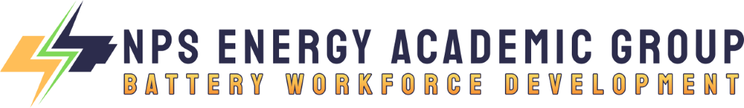
Battery Workforce Development Stakeholder Group (BWD SG)
Meeting Agenda & Action Planner
Program Year 1 (2023-24) / Phase I(b) / 3rd Meeting
Meeting Date & Time | 08 November 2023 – 1000 PT / 1300 ET
Core Members in Attendance | Peter Ateshian, NPS  Andrew Jennings, NPS  Arnie Dupuy, NPS  Coleen McHenry, NPS  Mary Sims, NPS  Stacey Johnson, NENY  Bernie Kotlier, NABWC  Brian Kildee, IFPTE  Dan Nussbaum, NPS  Alex Dupuy  Nelson Emmons, NPS  Eric Shields  Eric South  Frank DarConte  Scott Gemperline, National Mining Association  Daniel Hicks  Morgan Bazilian, CO School of Mines  Peng Zhang  Richard Coyle  Rick Geddes  Robert Cekuta  Slowa ?  Vijay Dhar, NABWC  Adrian Volintiru
Core Members Absent | Kristie Kelly, CEWD  AnnMarie Scheidt  Yacov Shamash  Vyacheslav Solovyov  Patricia Malone  Maria Sicari  Doreen Harris  Kyle Roelofs  Cliff Whitcomb, Cornell University  Jess F  Rabia Khan  J Brown  S Fung  Wes Anderson  Faraz Khan, IFPTE  M McVay  Kaan Ozbay  Derek O'Connor
Guest Attendees & Roles
Relevant Documents  Preparatory reading to accompany topic discussions | State of Critical Minerals Report – Payne Institute, CO School of Mines
Link to Previous Minutes | None – To be provided going forward

Vision Statement | Increase and improve the domestic battery supply chain workforce to a level that supports effective self-sufficiency and enhances national security in accordance with goals established at the Federal level.
Focusing Goals  for this Meeting | - Discuss progress to date.  - Learn about latest developments in selected member organizations.  - Identify action items that support future progress, particularly creation of courses of action (COAs) to fill workforce gaps.
Agenda
Item # | Time Window | Topic Title - Presenter | Notes
1 | 1000-1020 | Research State of Play  NPS | NPS presented attached ppt brief, noting preliminary impressions coming out of the research. There is general agreement throughout the group that some type of coordinating body is required for the battery industry; to represent the interests of industry and the government as well as call on the resources of both in conjunction with the academy.  Member noted that coordination between sectors is also needed and this program presents the opportunity to figure out how we get this coordination started properly.  Member asks: How far will recommendations go for a coordinating body? Will it be DOD or Federal-wide? NPS notes that these recommendations are going to the Acquisition and Sustainment part of the DoE, so if this research team does well then it's possible that it could get attention across the Departments.
2 | 1020-1030 | Purpose + Status of Assessment  NABWC | Presenting to FCAB tomorrow. Executive director for California Labor management committee and volunteer for LI-bridge. Mission:  1 – Assess workforce needs of advanced battery industry.  2 – collect a catalog in advanced battery workforce and training (and battery related), publicly available and free resource.  3 – Results of assessment and catalog and compare them to see what is missing (avoid duplication but want to fill the gaps).  Where they are currently – assessment is sub-contracted to center for automotive research (CAR). Questionnaire should be done by 21 December. Objective 2 is going to require much funding and resources and will see if FCAB will help provide the resources to complete this. NPS asked meeting participants to complete the survey request from CAR. Due date can be extended for those who are receiving it today. Objective 2 will require “many-millions”.
3 | 1030-1040 | Battery Academy + Activity Update  NENY | Briefer: Director for Workforce Development for New Energy New York.  Presenting to FCAB on workforce tomorrow and primary concern is that anyone can put something on the web for training (potential for accidents). Central coordinator can provide the authority for certification of training programs.  $113 million for battery energy storage development and deployment. Secured Battery-NY site in NY opportunity zone. Built and launched supply chain database. Launched New York Battery Academy. Supply chain database is publicly available. Broome-Tioga BOCES programs in batteries – meeting students from 3rd grade and middle school to introduce these careers to kids early. SUNY Broome lab spaces for hands on training.
4 | 1040-1050 | CO SoM Outtakes  Dir – Payne Institute | Moved there from the World bank and UN. Mining Schools Act working its way through Congress now. Difficult to attract students in these areas – even less on the processing. Big assumption – policy directions may change. While industrial policy was out of favor for a long time, that does not mean it will stay that way. Assumption that we will be doing this only in America that may be deeply flawed. Permitting, funding, policy, etc. are all far behind the “batteries” discussion and development. We should make this explicit – this is largely due to a political development and economic/trade war with China.
5 | 1050-1100 | Closing Remarks + Action Planning  NPS | Next meeting – 17 Jan 24

