Wayne P. Hughes Naval Warfare Studies Institute hosts interactive discussion on Maneuver Warfare, MCDP-7, and the importance of Learning in the Cognitive Era
Mie Augier & Randy Pugh
The Naval Warfare studies Institute (NWSI)’s critical thinking and judgment branch hosted a student led, interactive discussion on the topic of the art and science of learning for warfighters in the post industrial / cognitive era. As the recently published “Advantage at Sea”, a Tri Service Maritime Strategy signed by the Commandant of the Marine Corps, Chief of Naval Operations, and the Commandant of the Coast Guard, noted: “Transforming our learning model for the 21st century will enable us to adapt and achieve decision advantage in complex, rapidly changing operating environments”. The USMC in particular has signaled learning as an important institutional priority, with the publication of the CPG and especially the MCDP-7 on Learning. Initiated by remarks by NPS graduate Maj Sean Barrett on the intellectual and institutional history from FMFM-1 and MCDP-7 on learning, NPS students were presenting the results of their thesis in support of this important theme (in the context of maneuver warfare); including how to create mechanisms for enabling and leading learning organizations; the importance of developing critical and creative problem solving skills and aptitudes for lifelong learning. Students from several departments and schools, recent graduates, and Col GI Wilson (ret) and MajGen Mullen (ret) participated in the subsequent discussion including also topics such as how to change how we teach (to support developing active minds through active learning approaches); how to develop a passion for lifelong learning; the centrality of learning for being able to implement maneuver warfare; and the importance of critical and creative thinking and intellectual readiness.
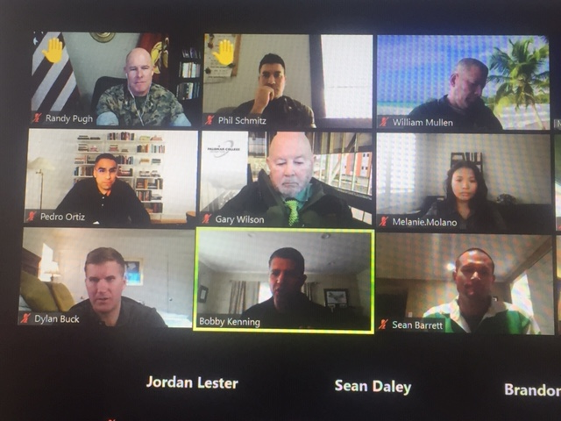

NWSI’s critical thinking and judgment branch aims to support the development of intellectual readiness in the cognitive era, and honor the ideas and work of Wayne P. Hughes and General Al Gray, who founded MCU on the vision of teaching critical thinking and judgment. 89755

